Daniela Gonzalez
11/21/25

Reflection Questions Assignment 02

- Before beginning the project: How much time do you anticipate it will take you to make a successful call with your application to Spotify’s “new-releases” endpoint?
    - Just at a glance from reading the assignment and not being entirely sure what I need to do I anticipate this to take me at least 3-5 hours. I confess that I am a bit behind and a tad bit confused on how to do this assignment, but I am eager to take on the challenge.
- After completing the project: How much time did it actually take you to successfully hit the Spotify “new-releases” endpoint with your application?
    - Through quite a bit of trial and a lot of errors I managed to get the correct response in 4 hours total.
- What authentication and authorization flow did you decide to use and why did you feel that was best?
    - As I was reading the spotify documentation links, it specified that they implement the OAuth 2.0 Authorization framework. So that is what I will be following.
- Did you successfully get return data on new release albums from the Spotify API? If you did not:
  - At what place did you get stuck?
    - I did not get the correct information to populate when I tried to get the data. To be honest I don’t actually know for certain where I got stuck, but I can assume that my ‘SpotifyApiService’ is not quite right. Another possible issue is that I am lost on how exactly to get the access token or if I even did the client Id portion right. I will definitely be asking for look at what I am doing wrong.
  - Did you simply run out of time? Or did you encounter a problem that you could not figure out how to get around?
    - I was having an issue with not receiving emails and since I missed class on Tuesday 11/18 I did not give myself enough time to really work through these issues. Looking back to the GitHub and the reading has really helped me, but I have no one to blame but myself for not checking the blackboard sooner.
    - I want to say that given the short notice of finding out about the assignment, I sadly could not ask the questions I could have asked to clarify some instruction. This is entirely my own fault for being unprepared.
- What difficulties did you encounter when working through this project? Please go into some detail on bumps in the road you encountered.
    - I encountered most of my road bumps when I came to getting the expected outcome. I don’t completely understand how it fixed my issue but added the portion of code that converts ‘authBytes’ to a ‘64string’ token seemed to fix my issue.
    - That and putting the ‘ClientId’ and ‘ClientSecret’ in the right places in the ‘appsettings.json’ file. I kept running into issues of the system, not being able to find the info when I ran the program in the place it was. I accidentally had the info nested inside of the ‘connectionstrings’ portion instead of the root like the code the ‘SpotifyApiService’ code was expecting.
- If you used AI to assist in completing this project, please talk about how you used it. Did AI help? Were there some things that it was not helpful with?
    - I used AI to help me understand what the assignment was asking of me and to clarify certain things in my code, they were things that I read about in the readings provided, but needed more insight into the mechanics of.
    - I added a section this section
at the recommendation of AI, I am not sure of its exact purpose because I confused myself on the reading. But when I put this code back into my final draft it got the API to work. I will be asking clarification questions on this.
    - I found that AI helps to give a different perspective of what needs to be done but it is not “all knowing”. Often times if I don’t inform myself with the lectures and reading the sources that are provided on the class Notion page, I find that AI is confusing to explain certain concepts. And when I know the concepts I find that AI is missing elements that can simplify the work to provide an easier answer. All of this is to say that AI can also be confusing to understand but it does help when I am in a pinch and gives a different perspective when I want to clarify an issue.
- What are your thoughts on the Spotify documentation?
    - The Spotify Documentation is very thorough, but also kind of lacking. Give the redirect URL for example, I first put in there https://localhost:5000 thinking that was what I needed to add for this assignment and it have me an explanation about why ‘localhost’ would not work but what it did not do was offer an explanation about what to look for what trying to add a redirect URL.
    - I especially appreciated the hyperlinks embedded in the paragraphs to show you what they are referring to.
- What are your thoughts on the overall process to obtain and use an access token to interact with the Spotify API?
    - Quite frankly I find it a bit confusing, I wish it were a bit more descriptive of where to obtain the access token. What I mean is that when you read the Spotify documentation for example it tells you the code you can use and how it works but doesn’t specify where to enter the code. I understand that it may seem obvious if the people reading the documentation are coders, but if I was reading it without any background info that I have I would not know where to put the code that they provided. I just think it would be a good recommendation to add a snippet of something along those lines.
    - That being said, after the initial confusion, I am still not quite sure of how to obtain and use an access token but I have a much better understanding of it then when I first started this assignment.
- Any additional reflections you would like to share?
    - One this I would like to say is that I would like, for future assignments, when it comes to using Spotify’s documentation, I would like a clarification to point for adding an example of what to put in the URL portion when creating an app. This portion below
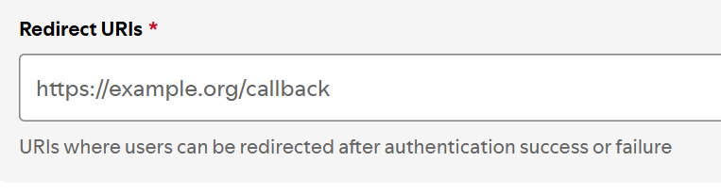
It would be nice to know what to put there for a clearer understanding of what to put to make it work with our assignment parameters.

